For quick and easy gourmet cooking look no further than Jerry’s Gourmet Food Company. All of our natural products take 5 minutes or less prep time to prepare and enjoy.  ALL OF OUR BEST SELLING DINNERS ARE $9.95 AND HAVE NO SALT/ALL NATURAL !  126N Southern Italian pasta  109N Old Fashion Pot Roast Ideal for effortless entertaining /no fuss hearty gourmet dinner.  116N Country Harvest Corn ChowderEveryone will lovethis rich flavorful chowder, a traditional farmhouse favorite.  127N Italian Farm Style ChickenHigh in protein, easy to prepare, and best of all kid approved. | A DELICIOUS EASY TO PREPARE MEAL WITH OLD FASHIONED HOMEMADE FLAVOR  Contact Us  800-584-5715  239-860-1347  Email: support@jerrysgourmetfoods.com  DISTRIBUTOR cODE #  ____________________ | JERRY’S  gOURMET  fOOD  cOMPANY
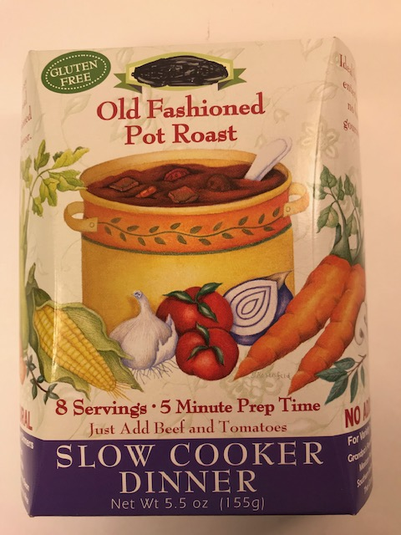  109N BEST SELLING SLOW COOKER DINNERS OLD FASHIONED POT ROAST  NEW PRODUCTS ALL $9.95 EACH  100N ESPRESSO CHOCOLATE LIQUEUR SAUCE  101N BURGUNDY WINE JELLY  102N ROASTED GARLIC BALSAMIC JAM  103N RASPBERRY MERIOT BALSAMIC JAM | 104N CHERRY CHIANTI BALSAMIC GLAZE  105N PINK PEPPERCORN PASTA SAUCE  106N ARTICHOKES SIMMERED WITH ZINFANDEL BREAD TOPPER  107N ARTICHOKE PARMESAN TAPENADE  108N KEY LIME MANGO RELISH  111N ITALIAN FARM STYLE CHICKEN DINNER  112N ROASTED GARLIC BALSAMIC JAM  113N KEY LIME GINGER WASABI MUSTARD  114N SUN-DRIED TOMATO & OLIVE BRUSCHETTA TOPPING  115N ROASTED RED PEPPERS & GOAT CHEESE TAPENADE  115N BLUEBERRY CHARDONNAY BALSAMIC JAM  VEGETARIAN MEALS  117N INDIAN CURRY WITH RICE  118N THAI CURRY LENTIL  119N FARMER’S HEARTY SPLIT PEA | 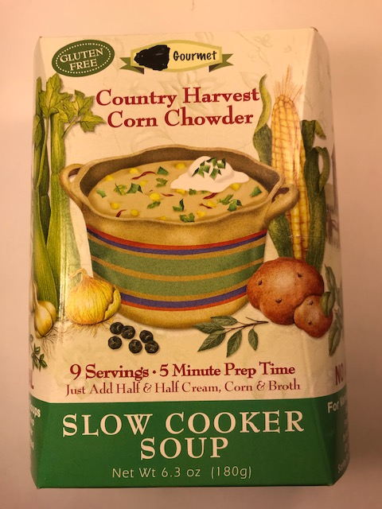  116N COUNTRY HARVEST CORN CHOWDER  NEWSLOW COOKER DINNERS  120N GRANDMA’S COUNTRY CHICKEN& RICE  121N BBQ BEANS & COUNTRY CORN BREAD  122N HAWAIIAN LUAU SWEET & SOUR  123N SOUTHWEST ROADHOUSE CHILI  124N HOMEMADE TURKEY BARLEY  125N FRENCH BISTRO SHORT RIBS

